Write out solutions for the following:
Functions
Create a function called ROOM that will determine how much a customer’s credit limit can be increased. The method to determine this amount is to find out the highest credit limit amount granted any of the customers. Then take the current customer and determine the amount between their current amount and that highest amount. That is how much of an increase they are allowed.
For example, in the output below, Euro+ Shopping Channel has their credit limit set to 227,600. They are allowed a 0 increase with the highest amount. Atelier graphique has a current credit limit of 21,000. Atelier graphique can be allowed up to 206,600 as an increase.
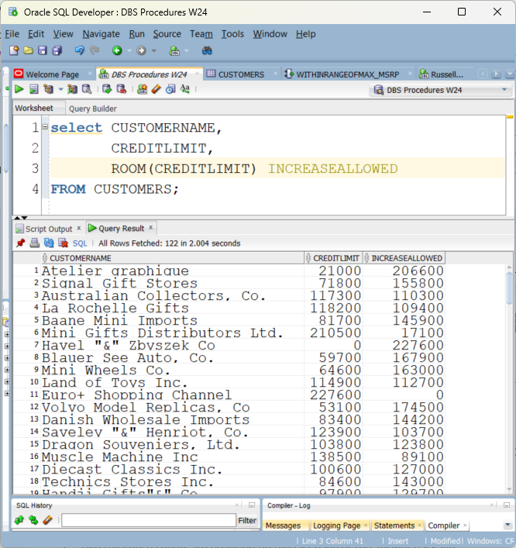

Procedures and cursors

Input: MyCustomers table (some of the columns – not all)
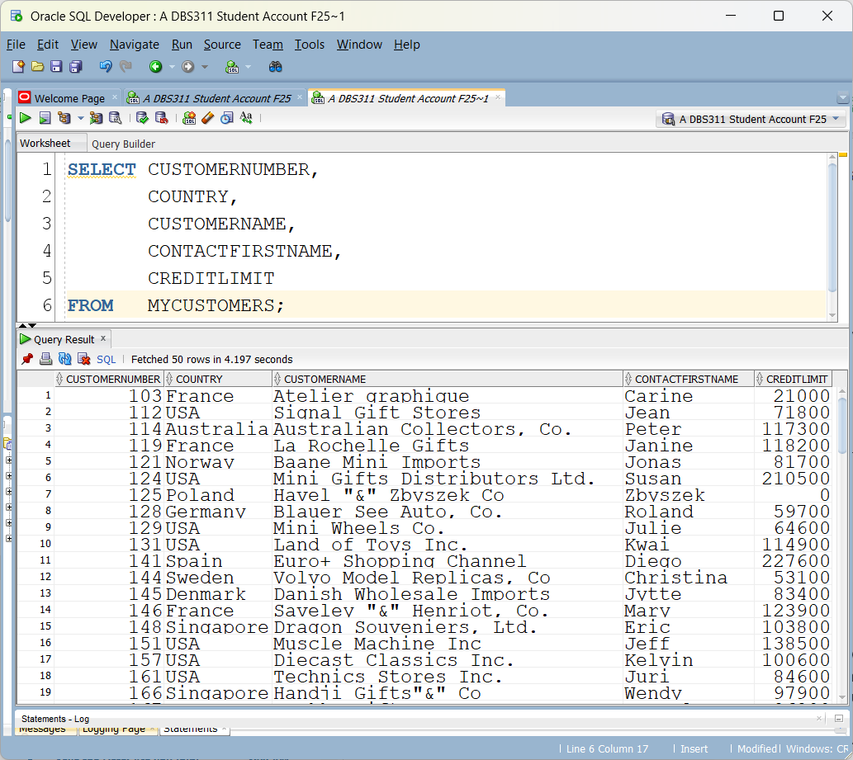
Input: CustPhone Table
(note a few customers have more than one phone number like #124)
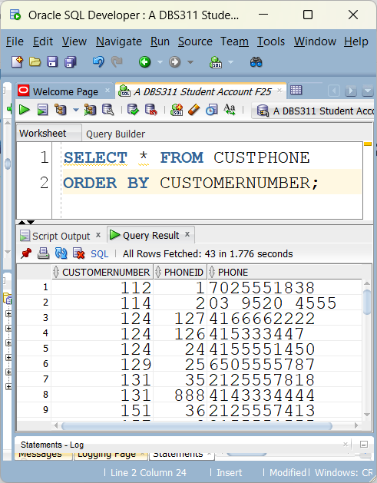
Provide the code to produce the following output without an actual update.
EXECUTE CREDITLIMITINCREASE(‘USA’,9000)
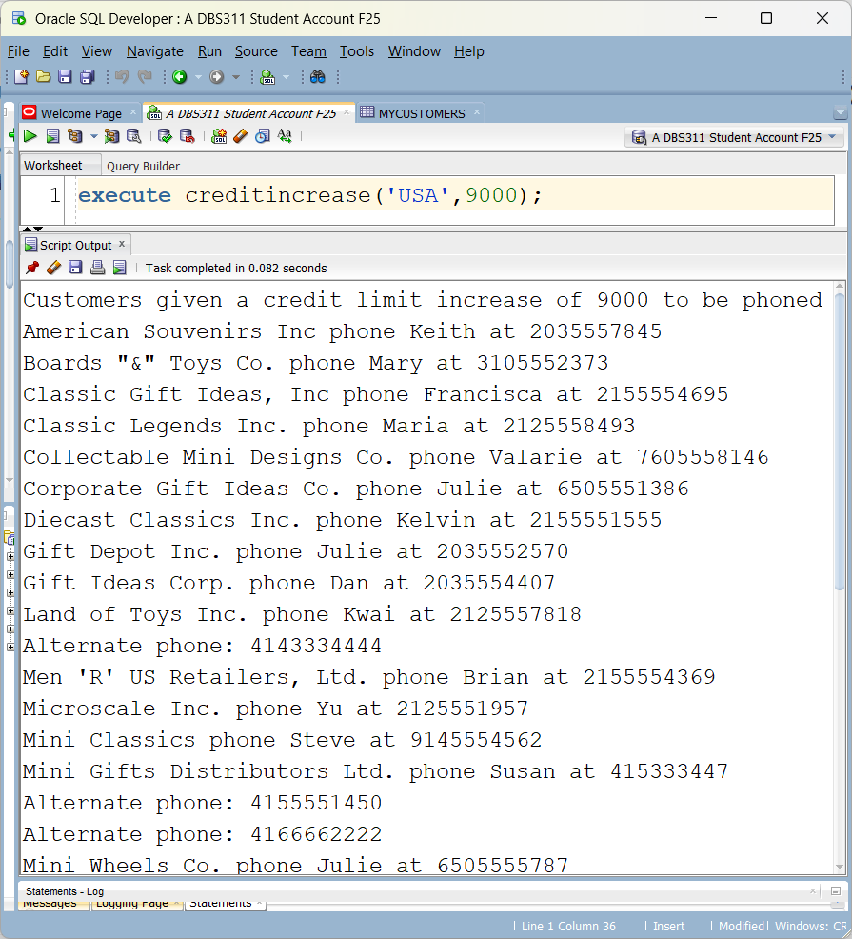

What would you change in your code to include the update?

Answer: Fill in the blanks
create or replace ______________ __________________
(
_____________ IN CHAR,

________________ IN NUMBER
) AS

BEGIN

-- USE back of this page to complete
CREATE TABLE CLERKSAUDIT (
audit_id NUMBER GENERATED BY DEFAULT AS IDENTITY PRIMARY KEY,
table_name VARCHAR2(255),
transaction_name VARCHAR2(10),
by_user VARCHAR2(30),
transaction_date DATE,
ID NUMBER(38,0),
JOB CHAR(5 BYTE),
DEPT NUMBER(38,0),
SALARYBEFORE NUMBER(7,2),
SALARYAFTER NUMBER(7,2)
);

Audit updates to Clerk salaries in an ClerksAudit table.
STAFF
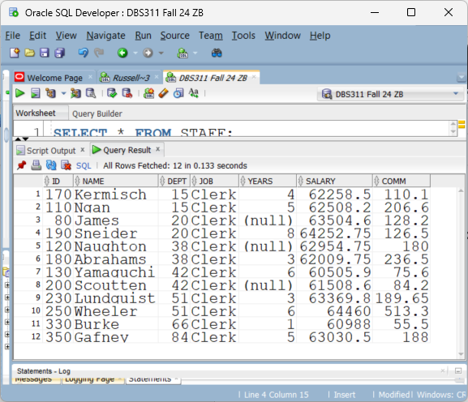
CLERKSAUDIT (before any updates) Audit ID is automatically generated.
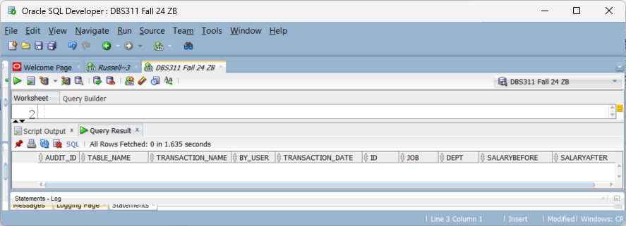
UPDATE APPLIED

UPDATE STAFF
SET SALARY = SALARY + 1000
WHERE DEPT = 20;
AFTER UPDATE

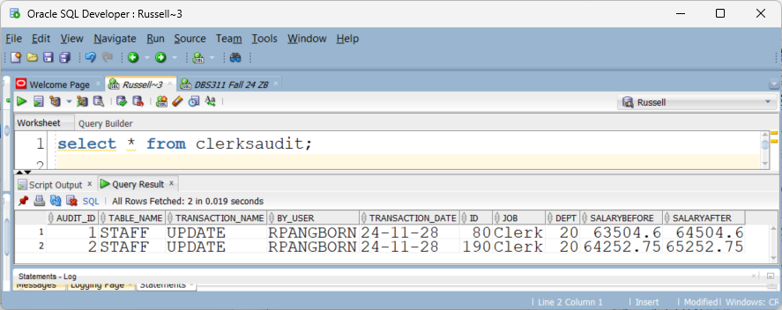
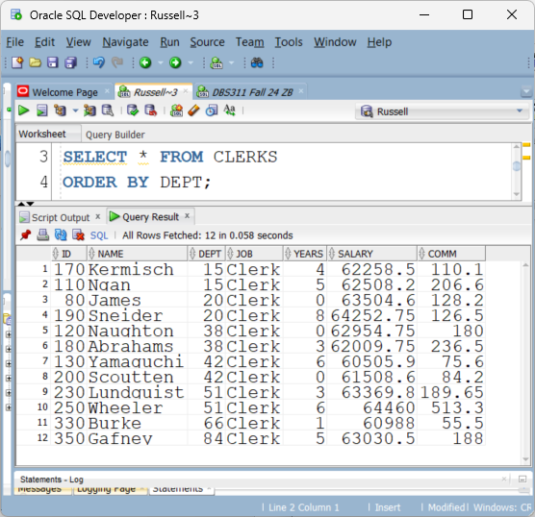
CREATE OR REPLACE CLERKRAISES

ON STAFF

______________ ___________________ ________________

DECLARE
A_TRANSACTION VARCHAR2(10);
POSITION CHAR(5 BYTE);

BEGIN
-- DETERMINE THE TRANSACTION TYPE

POSITION := ________________________

IF POSITION = 'Clerk' THEN

________ ______ CLERKSAUDIT (TABLE_NAME,
TRANSACTION_NAME,

________________
TRANSACTION_DATE,
ID,
JOB,
DEPT,
SALARYBEFORE,
SALARYAFTER)
VALUES('STAFF',
A_TRANSACTION,
________________,

_________________

______.ID,
______.JOB,
______.DEPT,
______.SALARY,

_________________);
END IF;
END;

{  "_id": 1,  "title": "The Bully Pulpit",  "author": "Doris Kearns Goodwin",  "duration": 2202,  "publisher": "Simon and Schuster Audio",  "narrator": "Edward Hermann",  "datepublished": {  "$date": "2013-11-05T14:10:30Z"  },  "genre": "Biography"  },  {  "_id": 2,  "title": "To Sleep in a Sea of Stars",  "author": "Christopher Paolini",  "duration": 2100,  "publisher": "Macmillan Audio",  "datepublished": {  "$date": "2020-09-15T14:10:30Z"  },  "genre": "Science Fiction",  "narrator": "Jennifer Hale"  },  {  "_id": 3,  "title": "Phantoms In The Brain",  "author": "Sandra Blakeslee",  "duration": 647,  "publisher": "Tantor Audio",  "narrator": "Neil Shah",  "datepublished": {  "$date": "2013-12-24T14:10:30Z"  },  "genre": "Non Fiction"  },  {  "_id": 4,  "title": "Letters from and Astrophysicist",  "author": "Neil deGrasse Tyson",  "duration": 335,  "publisher": "Audible Studios",  "narrator": "Neil deGrasse Tyson",  "datepublished": {  "$date": "2019-10-08T14:10:30Z"  },  "genre": "Non Fiction"  }, | {  "_id": 5,  "title": "Harry Potter and The Sorcerer's Stone",  "author": "J. K. Rowling",  "duration": 498,  "publisher": "Pottermore Publishing",  "narrator": "Jim Dale",  "datepublished": {  "$date": "2015-11-20T14:10:30Z"  },  "genre": "Childrens",  "series": "Wizarding World",  "megaseller": true  },  {  "_id": 6,  "title": "The Firm",  "author": "John Grisham",  "duration": 1030,  "publisher": "Random House Audio",  "narrator": "Scott Brick",  "datepublished": {  "$date": "2009-09-16T14:10:30Z"  },  "megaseller": true,  "genre": "Fiction"  },  { "_id": 7,  "title": "Take Your Breath Away",  "author": "Linwood Barclay",  "duration": 601,  "publisher": "Harper Audio",  "datepublished": {  "$date": "2022-05-17T14:10:30Z"  },  "genre": "Fiction",  "narrator": "Lauren Fortang"  },  { "_id": 8,  "title": "In Pieces",  "author": "Sally Field",  "duration": 641,  "publisher": "Hachette Audio",  "narrator": "Sally Field",  "datepublished": {  "$date": "2018-09-18T14:10:30Z"  },  "genre": "Biography" }
Collection name is booksreview
1. Show all the books where the genre is Fiction, but don’t include the Id and only show the title, author and date published
2. Change the author for book id 4 to an embedded document that includes first, last and middle name
3. Change the narrator for the book called Take Your Breath Away to a set of several narrators that include the original narrator and also Hillary Huber and Peter Simonelli.
4. A mistake was made with the duration of all the books. The duration in minutes should be an extra 5 minutes. Fix this.
During the review 6 more MongoDB questions will be done relating to the collection.

